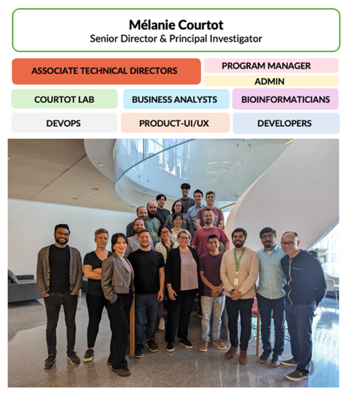
The Genome Informatics program at the Ontario Institute for Cancer Research (OICR) builds the software, data models, and standards that let researchers around the world store, organize, and compute over massive, complex genomic and clinical datasets.
From ontologies to petabyte-scale platforms, our work spans the full stack of biomedical data, turning raw genomic and clinical data into something researchers and clinicians worldwide can trust, find, and use to improve human health.
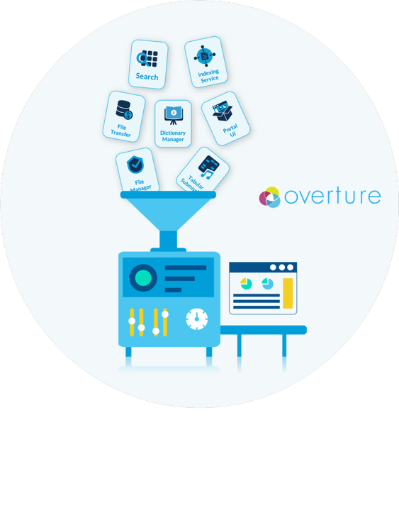
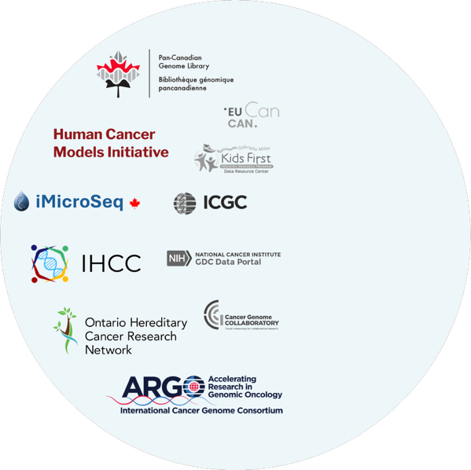
Our unique ability to build a diverse portfolio of data platforms rests on our reusable software suite, Overture. Developed at OICR and released as open source, Overture lets our engineers and teams elsewhere build systems that help researchers and consortiums across disciplines store, organize, explore, and share their massive research datasets. It is built from modular components covering data submission, file transfer, search, and exploration, which can be used on their own or combined into a complete data portal, for single labs or large consortia. With 8+ years of stable releases, Overture powers seven production platforms including ICGC-ARGO, the Ontario Hereditary Cancer Research Network (OHCRN), the Human Cancer Models Initiative, iMicroSeq, and the Pan-Canadian Genome Library.

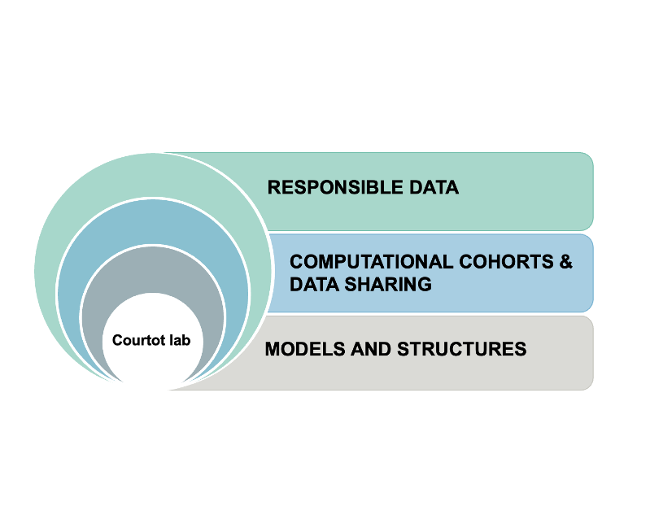
The Courtot Lab (established 2023) is the research arm of the Genome Informatics team at OICR, bringing together software engineering, data science, and biomedical knowledge representation to make large-scale genomics data findable, accessible, and usable for research and clinical care. Our research centers on enabling more sophisticated biomedical data integration and knowledge representation, applied to the health domain, organized around three foundational themes:

- Knowledge representation for biomedical data. We design ontologies and data standards for clinical and research use cases that are widely (re)used; e.g. the ICGC-ARGO data model underpins several funded projects, including the Marathon of Hope Cancer Centres Network.
- Automated annotation and classification at scale. Building on work with the Gene Ontology and ontology-based classification systems, we develop methods to annotate and classify biomedical data automatically and generate new research hypotheses from it.
- Big data genomics platform design. Our research lab develops new software methods and AI-based tools that support data harmonization, curation, and discovery. These can then be ported back to the Overture suite for large-scale deployment.

Overture metrics and achievements

- 7 active research platforms run Overture in production, with first deployments dating to 2016
- 8+ years of stable production releases
- 19-person core team collaborating with 100+ external personnel across partner consortia and projects
- ~8 external engagements and consultations annually, with academic, clinical, and government institutions approaching the team to adopt Overture components or draw on the team's platform expertise
- ~9,000 unique visitors to overture.bio and docs.overture.bio from 46+ countries since 2024, growing 40%+ year over year

Overture is designed around FAIR (Findable, Accessible, Interoperable, Reusable) data-sharing principles and underpins major Canadian and international research infrastructure:
- ICGC-ARGO (2019): collects genomic and clinical data for 100,000+ participants across 27 programs in 15 countries, with 3,500+ registered users
- iMicroSeq (2021): 600,000+ pathogen genomes plus environmental wastewater data
- Pan-Canadian Genome Library (launching end 2026): federal genomic archive to support the secure, responsible, and collaborative sharing of Canadian human genomic data.
- OHCRN (2025): The Ontario Hereditary Cancer Research Network (OHCRN) is a province-wide program to centralize genetic and cancer-related data on inherited cancer syndromes and multi-modal cancer genomics
- OICR Drug Discovery Portal (2025): 405 million records, covering ~20,000 genes and spanning 32 different cancer types to find ideal candidates for cancer drug discovery.
- HCMI (2016): long-term funded contract (5th renewal in 2026) with NCI to maintain the Human Cancer Models Initiative data assets.
- IHCC (2020): long-running international human cohorts catalog, in collaboration with GA4GH and other consortia.

